# 

# APPLICATIONS AND RESULTS

## Test Systems

The proposed procedure (AOA) is applied on 34-bus standard radial distribution system and East Delta Network (EDN) radial distribution system as a part of the Unified Egyptian Network (UEN) in order to solve the optimal DGs and capacitors placement problem. The test systems data is shown in Appendix A. The results are compared with those obtained using other reported methods.

The proposed DG units can be classified into two types based on real and reactive power delivering as follows:

* DG injects only active power (i.e., operating at unity power factor), such as fuel cells, photovoltaic and micro-turbines.
* DG injects both active and reactive power (i.e., operating at power factor < 1), such as wind turbines and induction generators.

One type of capacitors is considered, which is fixed capacitors.

## Case Studies

The proposed procedure is applied on the test systems with four different cases are:

Case 0: without DGS and Capacitors (BFS algorithm results).

Case 1: With only DGs operating at unity power factor (p.f.), means that only active power injections.

Case 2: With only DGs operating at p.f. = 0.9, means that active and reactive power injections.

Case 3: With only capacitors, means that only reactive power injections.

Case 4: with both DGs at unity power factor and capacitors.

Case 5: with DGs at power factor 0.9 and capacitors

## Assumption and limits

The assumptions and the limits of constraints are considered as follows:

* The minimum and maximum limits of DG active power are 500 and 2000 kW, respectively.
* The minimum and maximum limits of capacitors are 150 and 2000 kVAR, respectively.
* The operating p.f. of DGs is unity in case 1, while it is 0.9 in cases 2 and 5.
* The minimum and maximum limits of voltage magnitude are 0.95 and 1.05 p.u., respectively.
* The maximum number of DGs possible locations (*NDGmax*) is 4.
* The maximum number of capacitors possible locations (*NCmax*) is 4.
* The maximum limit of the power of all DGs is 4000 kW
* The maximum limit of the power of all capacitors is 4000 kVAR

## Results

### Total power losss minimization

#### 34-bus radial distribution system

Tables 5.1-5.5 show the optimal locations and sizes of DGs and the capacitors required to reduce the total active power loss as an objective function for cases 1-5 for the 34-bus test system. Moreover, a comparison between the proposed procedure and other methods is presented.

Table 5.1 presents the optimal solution for case 1 using the proposed procedure, when only active power from DGs is injected. It can be observed that, the initial power loss without DGs is reduced from 221.752 kW to 74.4167 kW after placement of DGs. The optimal locations of DGs are at buses {23,31} with total rating power 3000 kW. Moreover, the minimum and maximum voltage magnitudes are improved.

Table ‎5‑1 A comparison between the power loss minimization using the proposed procedure with other methods using only the DGs at unity power factor (case 1) for 34-bus test system

|  |  |  |  |  |  |  |  |  |  |  |  |
| --- | --- | --- | --- | --- | --- | --- | --- | --- | --- | --- | --- |
| Items | Un-compensated  (Case 0) | Compensated (Case 1) | | | | | | | | | |
| DPS [10] | | Analytical Method [11] | | MBFO  [12] | | GA [13] | | Proposed procedure | |
| Optimal locations and sizes of DGs (kW) | - | 27 | 2500 | 21 | 2884.8 | 21 | 2951.7 | 4 | 500 | 23 | 1847.5 |
| - | - | - | - | - | - | 7 | 500 | 31 | 1152.5 |
| - | - | - | - | - | - | 17 | 500 | - | - |
| - | - | - | - | - | - | 21 | 500 | - | - |
| - | - | - | - | - | - | 25 | 500 | - | - |
| - | - | - | - | - | - | 28 | 500 | - | - |
| Total size | - | 2500 | | 2884.8 | | 2951.7 | | 3000 | | 3000 | |
| **Total losses (kW)** | **221.752** | **118.8** | | **93.838** | | **93.751** | | **83.84** | | **74.416** | |
| TVD | 0.0483 | 0.0086 | | 0.0079 | | 0.0074 | | 0.0108 | | 0.0046 | |
| Minimum bus voltage(p.u.) | 0.9417 (#27) | 0.9750 (#34) | | 0.9773 (#34) | | 0.9777 (#34) | | 0.9723 (#27) | | 0.9832 (#27) | |
| Maximum bus voltage(p.u.) | 0.9941 (#2) | 1.0034 (#27) | | 0.9971 (#2) | | 0.9971 (#2) | | 0.9972 (#2) | | 0.9972 (#2) | |
| Overallpower factor | 0.85 | 0.5967 | | 0.5205 | | 0.5058 | | 0.4949 | | 0.4949 | |

Table 5.2 presents the optimal solution for case 2 using the proposed procedure, when active and reactive power from DGs are injected. It can be observed that, the initial power loss without compensation is reduced from 221.752 kW to 25.348 kW after placement of DGs. The optimal locations of DGs are at buses {23,10} with total rating power 3000 kW and 1452.9 kVAR. Moreover, the minimum and maximum voltage magnitudes are improved after placement of DGs.

|  |  |  |  |  |  |  |
| --- | --- | --- | --- | --- | --- | --- |
| Table ‎5‑2 A comparison between the power loss minimization using the proposed procedure with other methods using only the DGs at 0.9 power factor (case 2) for 34-bus test system | | | | | | |
| Items | Un-compensated  (Case 0) | Compensated (Case 2) | | | | |
| Analytical Approach [18] | | | Proposed procedure | |
| Optimal locations and sizes of DGs (kW, kVAR) | - | Locations | DG Size (kW) | - | Locations | DG size (kW) |
| 20 | 3231.8 | - | 23 | 1863.3 |
| - | - | - | 10 | 1136.7 |
| - | - | - |  |  |
| Total size | - | - | 3231.8 | - | - | 3000 |
| **Total losses (kW)** | **221.752** | **49.415** | | | **25.348** | |
| TVD | 0.0483 | 0.004 | | | 0.0023 | |
| Minimum bus voltage(p.u.) | 0.9417 (#27) | 0.9832 (#34) | | | 0. 9888 (#27) | |
| Maximum bus voltage(p.u.) | 0.9941 (#2) | 1.0015 (#20) | | | 0.9978 (#2) | |
| Overall power factor | 0.85 | 0.85 | | | 0. 7552 | |

Table 5.3 presents the optimal solution for case 3 using the proposed procedure, when only reactive power from capacitors is injected. It is clear that, the initial power loss without compensation is reduced from 221.752 kW to 160.4252 kW after placement of capacitors. The optimal locations of capacitors are at buses {18,9,24} with total rating power 2482.5 kVAR. Moreover, the minimum and maximum voltage magnitudes and overall system power factor are improved.

Table ‎5‑3 A comparison between the power loss minimization using the proposed procedure with other methods using only the capacitors (case 3) for 34-bus test system

|  |  |  |  |  |  |  |  |  |  |  |  |
| --- | --- | --- | --- | --- | --- | --- | --- | --- | --- | --- | --- |
| Items | Un-compensated  (Case 0) | Compensated (Case 3) | | | | | | | | | |
| PGSA [14] | | BFA [15] | | GA [16] | | APSO [17] | | Proposed procedure | |
| Optimal locations and sizes of capacitors (kVAR) | - | 19 | 1200 | 9 | 600 | 7  buses | 1629 | 19 | 1050 | 18 | 896.88 |
| 20 | 200 | 22 | 900 | 25 | 750 | 9 | 758.562 |
| 22 | 639 | - | - | - | - | 24 | 862.755 |
| Total size | - | 2039 | | 1500 | | 1629 | | 1800 | | 2482.5 | |
| **Total losses (kW)** | **221.752** | **169.167** | | **169.07** | | **168.955** | | **168.023** | | **160.4252** | |
| TVD | 0.0483 | 0.0368 | | 0.0394 | | 0.0408 | | 0.0375 | | 0.0344 | |
| Minimum bus voltage(p.u.) | 0.9417 (#27) | 0.9492 (#27) | | 0.9503 (#27) | | 0.9491 (#27) | | 0.9416 (#27) | | 0.9503 (#27) | |
| Maximum bus voltage(p.u.) | 0.9941 (#2) | 0.995 (#2) | | 0.9948 (#2) | | 0.9948 (#2) | | 0.9949 (#2) | | 0.9952 (#2) | |
| Overallpower factor | 0.85 | 0.9842 | | 0.9588 | | 0.9658 | | 0.9738 | | 0.9965 | |

Table 5.4 presents the optimal solution for case 4 using the proposed procedure, when active power from DGs is injected and reactive power is injected from capacitors. It can be observed that, the initial power loss without compensation is reduced from 221.752 kW to 18.15 kW after placement of DGs and capacitors. The optimal locations of DGs are at buses {9,21,25} with total rating power 3000 kW and the optimal locations of capacitors are at buses {7,24} with total power rating 1927 kVAR. Moreover, the minimum and maximum voltage magnitudes are improved after placement of DGs and capacitors.

Table ‎5‑4 A comparison between the power loss minimization using the proposed procedure with other methods using DGs at unity power factor and capacitors (case 4 ) for 34-bus test system

|  |  |  |  |  |  |
| --- | --- | --- | --- | --- | --- |
| Items | Un-compensated  (Case 0) | Compensated (Case 4) | | | |
| Proposed procedure | | |
| Optimal locations and sizes of DGs (KW) | - | 9 | | 952.8 |
| 21 | | 1125.5 |
| 25 | | 921.6 |
| Total DGs size |  | 3000 | | |
| Optimal locations and sizes of capacitors (KVAR) |  | 7 | 1110.4 | |
| 24 | 816.6 | |
|  |  | |
| Total capacitors size | - | 1927 | | |
| **Total losses (kW)** | **221.752** | **18.15** | | |
| TVD | 0.0483 | 0.0023 | | |
| Minimum bus voltage(p.u.) | 0.9417 (#27) | 0.9892 (#33) | | |
| Maximum bus voltage(p.u.) | 0.9941 (#2) | 0.998 (#2) | | |
| Overallpower factor | 0.85 | 0.8656 | | |

Table 5.5 presents the optimal solution for case 5 using the proposed procedure, when active power and reactive power from DGs are injected and reactive power is injected from capacitors. It can be observed that, the initial power loss without compensation is reduced from 221.752 kW to 17.11 kW after placement of DGs and capacitors. The optimal locations of DGs are at buses {31,24,21} with total rating power 3000 kW and the optimal locations of capacitors are at buses {8} with total power rating 1112.9 kVAR. Moreover, the minimum and maximum voltage magnitudes are improved after placement of DGs and capacitors.

|  |  |  |  |  |  |  |
| --- | --- | --- | --- | --- | --- | --- |
| Table ‎5‑5 A comparison between the power loss minimization using the proposed procedure with other methods using DGs at .9 power factor and capacitors (case 5) for 34-bus test system | | | | | | |
| Items | Base case |  | Case 5 | |
|  | FPA [9] | Proposed method |
| DG size (kW, kVAR) and location | - |  | 2086, 1292.8 (#26) | 799.3, 387.09 (#31),  946.5, 458.37 (#24),  1254.2, 607.39 (#21) |
| Capacitor size (kVAR) and location | - |  | 1250 (#26) | 365.568 (#8) |
| Total size of DGs (kW, kVAR) | - |  | 2086, 1292.8 | 3000, 1452.86 |
| Total size of capacitors (kVAR) | - |  | 1250 | 1112.9 |
| ***f1* [Loss (kW)]** | **221.752** |  | **58.8298** | **17.1153** |
| TVD | 0.0483 |  | 0.007 | 0.0021 |
| Min. voltage (p.u.) | 0.9417 (#27) |  | 0.9751 (#34) | 0.99 (#12) |
| Overall p.f. | 0.85 |  | 0.8436 | 0.8405 |

From these Tables, the total power loss, the total active and reactive power injections using the proposed procedure are lower than that obtained using the other methods. Case 2 gives better results than other cases. Moreover, the overall power factor is improved after placement of DGs and capacitors. In addition, the overall power factor is within permissible limits. Therefore, this comparison reflects to the great capability of the proposed procedure to find the optimal locations and sizes of DGs and capacitors in order to reduce the total power loss and improve the system reliability.

Fig. 5.1 and Fig. 5.2 shows the convergence curves of the AOA algorithm to reduce the total power loss using the DGs and capacitors for 34-bus test system. It is clear that, the AOA algorithm is able to reach the optimal solution with more accuracy and efficiency.

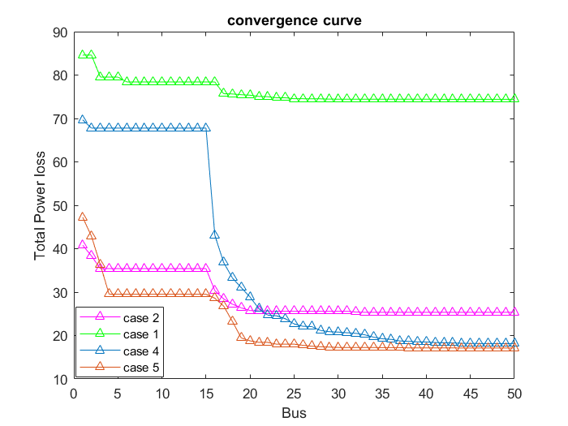

Figure ‎5‑1 convergence curve for IEEE-34 network (objective function: Total power loss minimization)

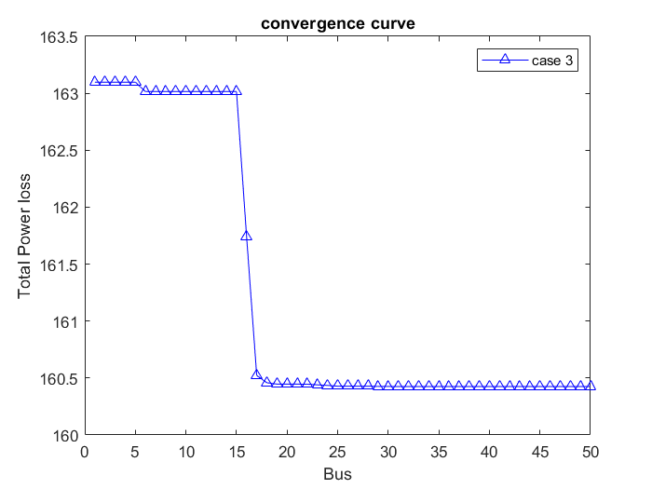

Figure ‎5‑2 convergence curve for IEEE-34 network (objective function: Total power loss minimization)

Fig. 5.3 shows the voltage profiles for cases 0-5, when the total power loss minimization is considered as an objective function. The voltage profiles are improved at cases 1-5, where the voltage profile improvement based on case 2 is better than that obtained from other cases, while the average values of voltages are 0.9658,0.9855, 0.9913, 0.9706 and 0.9895 for cases 1-5, respectively. Moreover, the minimum voltage limit is violated at buses starts from 22 to 27 in case 0.

Figure ‎5‑3 voltage profile for IEEE-34 network (objective function: Total power loss minimization)

#### EDN radial distribution system

Tables 5.6-5.10 show the optimal locations and sizes of DGs and the capacitors required to reduce the total active power loss as an objective function for cases 1-5 for the EDN system.

Table 5.6 presents the optimal solution for case 1 using the proposed procedure, when only active power from DGs is injected. It can be observed that, the initial power loss without DGs is reduced from 805.73 kW to 542 kW after placement of DGs. The optimal locations of DGs are at buses {21,25} with total rating power 4000 kW. Moreover, the minimum and maximum voltage magnitudes are improved.

Table ‎5‑6 Optimal locations and sizes of DGs at unity power factor using the proposed method for EDN system (case 1)

|  |  |  |  |
| --- | --- | --- | --- |
| Items | Un-compensated  (Case 0) | Compensated (Case 1) | |
| Optimal locations and sizes of DGs (kW) | - | 21 | 1999.9 |
| 25 | 2000 |
| Total size | - | 3999.9 | |
| **Total losses (kW)** | **805.73** | **542.459** | |
| TVD | 0.0439 | 0.0225 | |
| Minimum bus voltage(p.u.) | 0.9463 (#30) | 0.9669 (#23) | |
| Maximum bus voltage(p.u.) | 0.9854 (#2) | 0.9874 (#2) | |
| Overallpower factor | 0.8457 | 0.7932 | |

Table 5.7 presents the optimal solution for case 2 using the proposed procedure, when active and reactive power from DGs are injected. It can be observed that, the initial power loss without compensation is reduced from 805.73 kW to 458 kW after placement of DGs. The optimal locations of DGs are at buses {25,21} with total rating power 4000 kW and 1937 kVAR. Moreover, the minimum and maximum voltage magnitudes are improved after placement of DGs.

Table ‎5‑7 Optimal locations and sizes of DGs at 0.9 power factor using the proposed method for EDN system (case 2)

|  |  |  |  |
| --- | --- | --- | --- |
| Items | Un-compensated  (Case 0) | Compensated (Case 2) | |
| Optimal locations and sizes of DGs (kW) | - | Locations | DG size (kW) |
| 25 | 2000 |
| 21 | 2000 |
|  |  |
| Total size | - | - | 4000 |
| **Total losses (kW)** | **805.73** | **458.85** | |
| TVD | 0.0439 | 0.0193 | |
| Minimum bus voltage(p.u.) | 0.9463 (#30) | 0. 9699 (#23) | |
| Maximum bus voltage(p.u.) | 0.9854 (#2) | 0.9879 (#2) | |
| Overallpower factor | 0.8457 | 0.8335 | |

Table 5.8 presents the optimal solution for case 3 using the proposed procedure, when only reactive power from capacitors is injected. It is clear that, the initial power loss without compensation is reduced from 805.73 kW to 673.69 kW after placement of capacitors. The optimal locations of capacitors are at buses {29,20,18,27} with total rating power 3743.01 kVAR. Moreover, the minimum and maximum voltage magnitudes and overall system power factor are improved.

Table ‎5‑8 Optimal locations and sizes of capacitors using the proposed method for EDN system (case 3)

|  |  |  |  |
| --- | --- | --- | --- |
| Items | Un-compensated  (Case 0) | Compensated (Case 3) | |
| Optimal locations and sizes of capacitors (kVAR) | - | 26 | 963.8 |
| 21 | 1198.9 |
| 8 | 782.9 |
| 18 | 1054.4 |
| Total size | - | 4000 | |
| **Total losses (kW)** | **805.73** | **673.69** | |
| TVD | 0.0439 | 0.036 | |
| Minimum bus voltage(p.u.) | 0.9463 (#30) | 0.9521 (#30) | |
| Maximum bus voltage(p.u.) | 0.9854 (#2) | 0.9865 (#2) | |
| Overallpower factor | 0.8457 | 0.9108 | |

Table 5.9 presents the optimal solution for case 4 using the proposed procedure, when active power from DGs is injected and reactive power is injected from capacitors. It can be observed that, the initial power loss without compensation is reduced from 805 kW to 474 kW after placement of DGs and capacitors. The optimal locations of DGs are at buses {22,25,18} with total rating power 4000 kW and the optimal locations of capacitors are at buses {11,25} with total power rating 1657 kVAR. Moreover, the minimum and maximum voltage magnitudes are improved after placement of DGs and capacitors.

Table ‎5‑9 A comparison between the power loss minimization using the proposed procedure with other methods using DGs at unity power factor and capacitors (case 4 ) for EDN system

|  |  |  |  |  |  |
| --- | --- | --- | --- | --- | --- |
| Items | Un-compensated  (Case 0) | Compensated (Case 4) | | | |
| Proposed procedure | | |
| Optimal locations and sizes of DGs (KW) | - | 22 | | 1458.3 |
| 25 | | 1374.3 |
| 18 | | 1167.4 |
| Total DGs size |  | 4000 | | |
| Optimal locations and sizes of capacitors (KVAR) |  | 11 | 495.3 | |
| 25 | 1162.6 | |
|  |  | |
| Total capacitors size | - | 1657.9 | | |
| **Total losses (kW)** | **805.73** | **474.879** | | |
| TVD | 0.0439 | 0.0208 | | |
| Minimum bus voltage(p.u.) | 0.9463 (#30) | 0.9682 (#24) | | |
| Maximum bus voltage(p.u.) | 0.9854 (#2) | 0.9879 (#2) | | |
| Overallpower factor | 0.8457 | 0.8277 | | |

Table 5.10 presents the optimal solution for case 5 using the proposed procedure, when active power and reactive power from DGs are injected and reactive power is injected from capacitors. It can be observed that, the initial power loss without compensation is reduced from 805 kW to 411 kW after placement of DGs and capacitors. The optimal locations of DGs are at buses {23,21,26} with total rating power 4000 kW and 1937 kVAR and the optimal locations of capacitors are at buses {18,4} with total power rating 1830 kVAR. Moreover, the minimum and maximum voltage magnitudes are improved after placement of DGs and capacitors.

Table ‎5‑10 A comparison between the power loss minimization using the proposed procedure with other methods using DGs at .9 power factor and capacitors (case 5) for EDN system

|  |  |  |
| --- | --- | --- |
| Items | Base case | Case 5 |
| Proposed method |
| DG size (kW, kVAR) and location | - | 687.7, 333.05 (#23),  1873.1, 907.19 (#21),  1439.2, 697.02 (#26) |
| Capacitor size (kVAR) and location | - | 1200 (#18)  630.8 (#4) |
| Total size of DGs (kW, kVAR) | - | 4000, 1937.156 |
| Total size of capacitors (kVAR) | - | 1830.8 |
| ***f1* [Loss (kW)]** | **805.73** | **411.4659** |
| TVD | 0.0439 | 0.0180 |
| Min. voltage (p.u.) | 0.9463 (#30) | 0.9714 (#24) |
| Overall p.f. | 0.8457 | 0.8711 |

Fig. 5.4 shows the voltage profiles for cases 0-5, when the total power loss minimization is considered as an objective function. The voltage profiles are improved at cases 1-5, where the voltage profile improvement based on case 2 is better than that obtained from other cases.

From these Tables, the total power loss is reduced using the proposed method. Case 2 gives the better results for the considered objective function and constraints than the other cases. Moreover, the overall power factor is improved after placement of DGs and capacitors. In addition, the overall power factor is within permissible limits.

Figure ‎5‑4 Voltage profile for EDN system (objective function: Total power loss minimization)

Fig. 5.5 and Fig. 5.6 shows the convergence curves of the AOA algorithm to reduce the total power loss using the DGs and capacitors for 34-bus test system. It is clear that, the AOA algorithm is able to reach the optimal solution with more accuracy and efficiency.

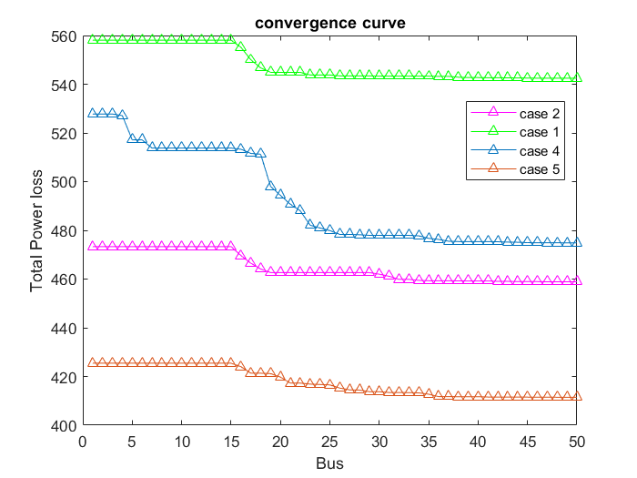

Figure ‎5‑5 convergence curve for EDN system (objective function: Total power loss minimization)

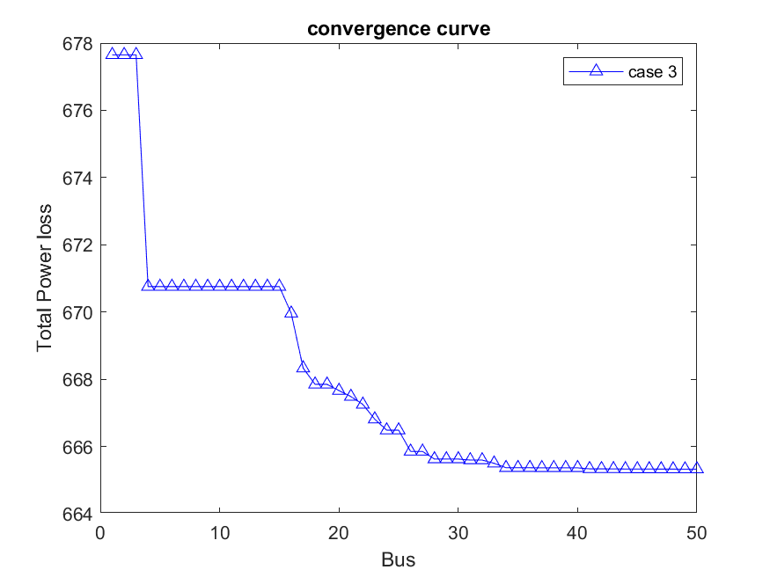

Figure ‎5‑6 convergence curve for EDN system (objective function: Total power loss minimization)

### TVD minimization

#### 34-bus radial distribution system

Tables 1.11-1.15 show the optimal locations and sizes of DGs and the capacitors required to reduce the total voltage deviation (TVD) as an objective function for cases 1-5 for the 34-bus test system. Moreover, a comparison between the proposed procedure and other methods is presented.

Table 5.11 presents the optimal solution for case 1 using the proposed procedure, when only active power from DGs is injected. It can be observed that, the initial TVD without DGs is reduced from 0.0483 to 0.0017 after placement of DGs. The optimal locations of DGs are at buses {26, 32} with total rating power 3500 kW. Moreover, the minimum and maximum voltage magnitudes are improved.

Table ‎5‑11 A comparison between the TVD minimization using the proposed procedure with other methods using only the DGs at unity power factor (case 1) for 34-bus test system

|  |  |  |  |  |
| --- | --- | --- | --- | --- |
| Items | Un-compensated  (Case 0) | Compensated (Case 1) | | |
| Proposed procedure | |
| Optimal locations and sizes of DGs (kW) | - | 26 | 1951.4 |
| 32 | 1548.6 |
| Total size | - | 3500 | |
| Total losses (kW) | 221.752 | 82.9864 | |
| **TVD** | **0.0483** | **0.0017** | |
| Minimum bus voltage(p.u.) | 0.9417 (#27) | 0.9883 (#20) | |
| Maximum bus voltage(p.u.) | 0.9941 (#2) | 0.9977 (#2) | |
| Overall power factor | 0.85 | 0.3678 | |

Table 5.12 presents the optimal solution for case 2 using the proposed procedure, when active and reactive power from DGs are injected. It can be observed that, the initial TVD without compensation is reduced from 0.0483 to 0.000496 after placement of DGs. The optimal locations of DGs are at buses {31, 24} with total rating power 3500 kW.

|  |  |  |  |
| --- | --- | --- | --- |
| Table ‎5‑12 A comparison between TVD minimization using the proposed procedure with other methods using only the DGs at 0.9 power factor (case 2) for 34-bus test system | | | |
| Items | Un-compensated  (Case 0) | Compensated (Case 2) | |
| Proposed procedure | |
| Optimal locations and sizes of DGs (kW, kVAR) | - | Locations | DG size (kW) |
| 31 | 1500.1 |
| 24 | 1999.9 |
| Total size | - | - | 3500 |
| Total losses (kW) | 221.752 | 24.32 | |
| **TVD** | **0.0483** | **0. 000496** | |
| Minimum bus voltage(p.u.) | 0.9417 (#27) | 0. 9932 (#19) | |
| Maximum bus voltage(p.u.) | 0.9941 (#2) | 1.0013 (#24) | |
| Overall power factor | 0.85 | 0. 6942 | |

Table 5.13 presents the optimal solution for case 3 using the proposed procedure, when only reactive power from capacitors is injected. It is clear that, the initial TVD without compensation is reduced from 0.0483 to 0.0295 after placement of capacitors. The optimal locations of capacitors are at buses {11, 10,26} with total rating power 3599.9 kVAR.

|  |  |  |  |
| --- | --- | --- | --- |
| Table ‎5‑13 A comparison between TVD minimization using the proposed procedure with other methods using only the capacitors (case 3) for 34-bus test system | | | |
| Items | Un-compensated  (Case 0) | Compensated (Case 3) | |
| Proposed procedure | | |
| Optimal locations and sizes of capacitors (kVAR) | - | 11 | 1200 | |
| 10 | 1199 | |
| 26 | 1200 | |
| Total size | - | 3599.9 | | |
| Total losses (kW) | 221.752 | 202.691 | | |
| **TVD** | **0.0483** | **0.0295** | | |
| Minimum bus voltage(p.u.) | 0.9417 (#27) | 0.9532(#27) | | |
| Maximum bus voltage(p.u.) | 0.9941 (#2) | 0.9956 (#2) | | |
| Overall power factor | 0.85 | 0.9879 | | |

Table 5.14 presents the optimal solution for case 4 using the proposed procedure, when active power from DGs is injected and reactive power is injected from capacitors. It can be observed that, the initial TVD without compensation is reduced from 0.0439 to  after placement of DGs and capacitors. The optimal locations of DGs are at buses {25 25 11} with total rating power 3500 kW and the optimal locations of capacitors are at buses {19, 6} with total power rating 1377.4 kVAR.

|  |  |  |  |  |  |
| --- | --- | --- | --- | --- | --- |
| Table ‎5‑14 A comparison between the power loss minimization using the proposed procedure with other methods using DGs at unity power factor and capacitors (case 4 ) for 34-bus test system | | | | | |
| Items | Un-compensated  (Case 0) | Compensated (Case 4) | | | |
| Proposed procedure | | |
| Optimal locations and sizes of DGs (KW) | - | 25 | | 818.3 |
| 25 | | 1043.9 |
| 11 | | 1637.8 |
| Total DGs size |  | 3500 | | |
| Optimal locations and sizes of capacitors (KVAR) |  | 19 | 821.6635 | |
| 6 | 555.721 | |
|  |  | |
| Total capacitors size | - | 1377.4 | | |
| Total losses (kW) | 221.752 | 38.4743 | | |
| **TVD** | **0.0483** |  | | |
| Minimum bus voltage(p.u.) | 0.9417 (#27) | 0.9914 (#20) | | |
| Maximum bus voltage(p.u.) | 0.9941 (#2) | 1.0002 (#11) | | |
| Overall power factor | 0.85 | 0.6049 | | |

Table 5.15 presents the optimal solution for case 5 using the proposed procedure, when active power and reactive power from DGs are injected and reactive power is injected from capacitors. It can be observed that, the initial power loss without compensation is reduced from 0.0439 to 2.3238e-04 after placement of DGs and capacitors. The optimal locations of DGs are at buses {10, 20, 25} with total rating power 3500 kW and the optimal locations of capacitors are at buses {17} with total power rating 1059.4 kVAR.

|  |  |  |  |  |  |  |
| --- | --- | --- | --- | --- | --- | --- |
| Table ‎5‑15 A comparison between the power loss minimization using the proposed procedure with other methods using DGs at .9 power factor and capacitors (case 5) for 34-bus test system | | | | | | |
| Items | | Base case |  | Case 5 | |
|  | Proposed method |
| DG size (kW, kVAR) and location | | | - |  | 1166.4, 564.8893 (#10),  993.1, 480.9892(#20),  1340.5, 649.2350 (#25) |
| Capacitor size (kVAR) and location | | | - |  | 1059.4 (#17) |
| Total size of DGs (kW) | | | - |  | 3500 |
| Total size of capacitors (kVAR) | | | - |  | 1059.4 |
| f1 [Loss (kW)] | | 221.752 | |  | 9.2909 |
| **TVD** | | **0.0483** | |  | **2.3238e-04** |
| Min. voltage (p.u.) | | 0.9417 (#27) | |  | 0.9955(#30) |
| Overall p.f. | | 0.85 | |  | 0.9946 |

Fig. 5.7 and Fig. 5.8 shows the convergence curves of the AOA algorithm to reduce the TVD using the DGs and capacitors for 34-bus test system. It is clear that, the AOA algorithm is able to reach the optimal solution with more accuracy and efficiency.

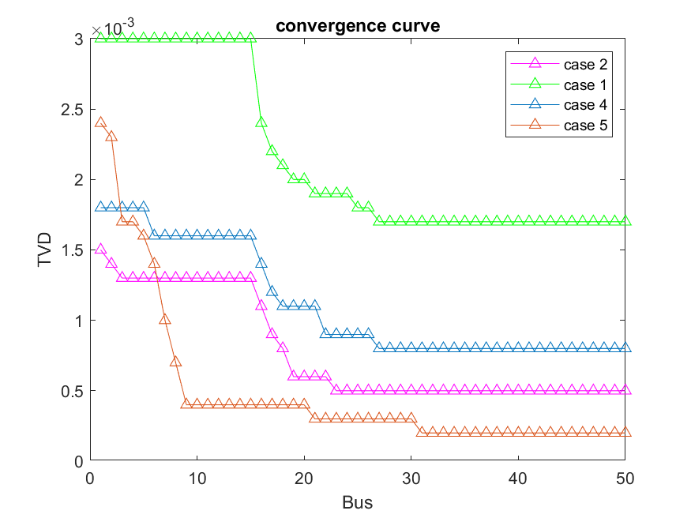

Figure ‎5‑7 convergence curve for IEEE-34 system (objective function: TVD minimization)

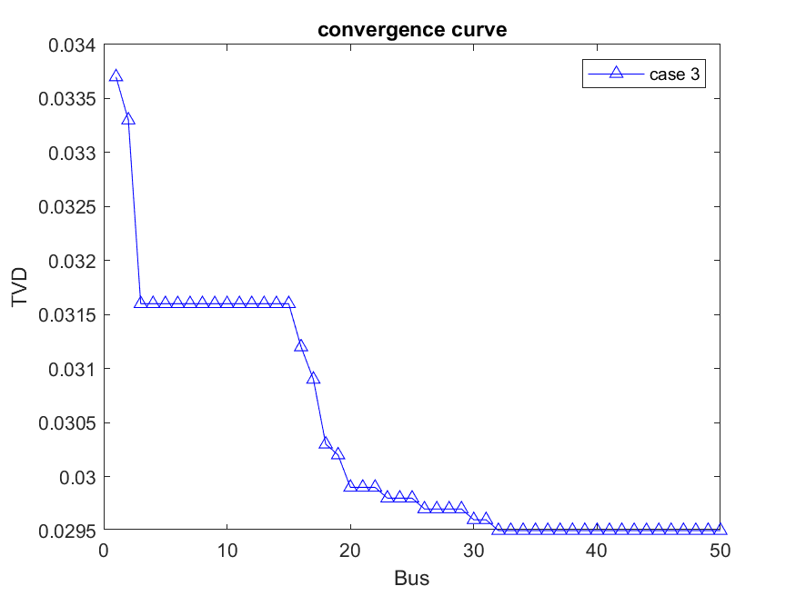

Figure ‎5‑8 convergence curve for IEEE-34 system (objective function: TVD minimization)

Fig. 5.9 shows the voltage profiles for cases 0-5, when the TVD minimization is considered as an objective function. The voltage profiles are improved at cases 1-5. Moreover, the minimum voltage limit is violated at buses starts from 22 to 27 in case 0.

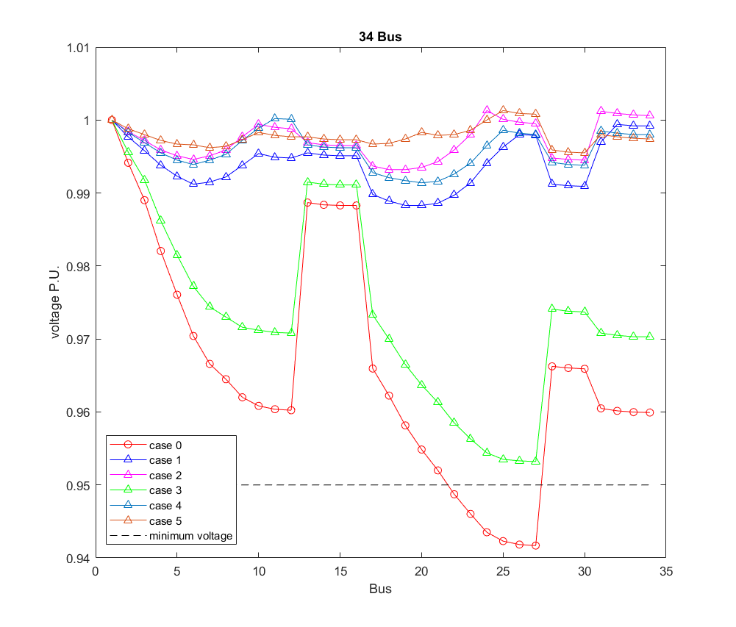

Figure ‎5‑9 Voltage profile for IEEE-34 system (objective function: TVD minimization)

#### EDN radial distribution system

Tables 5.16-5.20 show the optimal locations and sizes of DGs and the capacitors required to reduce the total voltage deviation (TVD) as an objective function for cases 1-5 for the EDN system. Moreover, a comparison between the proposed procedure and other methods is presented.

Table 5.16 presents the optimal solution for case 1 using the proposed procedure, when only active power from DGs is injected. It can be observed that, the initial TVD without DGs is reduced from 0.0439 to 0.0193 after placement of DGs. The optimal locations of DGs are at buses {26 29} with total rating power 4000 kW.

|  |  |  |  |
| --- | --- | --- | --- |
| Table ‎5‑16 Optimal locations and sizes of DGs at unity power factor to reduce TVD using the proposed method for EDN system (case 1) | | | |
| Items | Un-compensated  (Case 0) | Compensated (Case 1) | |
| Optimal locations and sizes of DGs (kW) | - | 26 | 1999.9 |
| 29 | 2000 |
| Total size | - | 3999.9 | |
| Total losses (kW) | 805.73 | 572.0918 | |
| **TVD** | **0.0439** | **0.0193** | |
| Minimum bus voltage(p.u.) | 0.9463 (#30) | 0.9677 (#21) | |
| Maximum bus voltage(p.u.) | 0.9854 (#2) | 0.9874 (#2) | |
| Overall power factor | 0.8457 | 0.7932 | |

Table 5.17 presents the optimal solution for case 2 using the proposed procedure, when active and reactive power from DGs are injected. It can be observed that, the initial TVD without compensation is reduced from 0.0439 to 0.0163 after placement of DGs. The optimal locations of DGs are at buses {28, 28} with total rating power 3999 kW.

|  |  |  |  |
| --- | --- | --- | --- |
| Table ‎5‑17 Optimal locations and sizes of DGs at 0.9 power factor using the proposed method for EDN system (case 2) | | | |
| Items | Un-compensated  (Case 0) | Compensated (Case 2) | |
| Optimal locations and sizes of DGs (kW) | - | Locations | DG size (kW) |
| 28 | 1999.7 |
| 28 | 1999.3 |
|  |  |
| Total size | - | - | 3999 |
| Total losses (kW) | 805.73 | 491.164 | |
| **TVD** | **0.0439** | **0.0163** | |
| Minimum bus voltage(p.u.) | 0.9463 (#30) | 0. 9703 (#20) | |
| Maximum bus voltage(p.u.) | 0.9854 (#2) | 0.9879 (#2) | |
| Overall power factor | 0.8457 | 0.8335 | |

Table 5.18 presents the optimal solution for case 3 using the proposed procedure, when only reactive power from capacitors is injected. It is clear that, the initial power loss without compensation is reduced from 0.0439 to 0.0326 after placement of capacitors. The optimal locations of capacitors are at buses {25 26 29 29} with total rating power 4000 kVAR.

|  |  |  |  |
| --- | --- | --- | --- |
| Table ‎5‑18 Optimal locations and sizes of capacitors using the proposed method for EDN system (case 3) | | | |
| Items | Un-compensated  (Case 0) | Compensated (Case 3) | |
| Optimal locations and sizes of capacitors (kVAR) | - | 25 | 441.5 |
| 26 | 1198.3 |
| 29 | 1194.8 |
| 29 | 1165.4 |
| Total size | - | 4000 | |
| Total losses (kW) | 805.73 | 712.8063 | |
| **TVD** | **0.0439** | **0.0326** | |
| Minimum bus voltage(p.u.) | 0.9463 (#30) | 0.9572 (#24) | |
| Maximum bus voltage(p.u.) | 0.9854 (#2) | 0.9865 (#2) | |
| Overall power factor | 0.8457 | 0.9108 | |

Table 5.19 presents the optimal solution for case 4 using the proposed procedure, when active power from DGs is injected and reactive power is injected from capacitors. It can be observed that, the initial TVD without compensation is reduced from 0.0439 to 0.0177 after placement of DGs and capacitors. The optimal locations of DGs are at buses {29, 29, 27} with total rating power 4000 kW and the optimal locations of capacitors are at buses {9, 27} with total power rating 1307 kVAR.

|  |  |  |  |  |  |
| --- | --- | --- | --- | --- | --- |
| Table ‎5‑19 A comparison between the TVD minimization using the proposed procedure with other methods using DGs at unity power factor and capacitors (case 4 ) for EDN system | | | | | |
| Items | Un-compensated  (Case 0) | Compensated (Case 4) | | | |
| Proposed procedure | | |
| Optimal locations and sizes of DGs (KW) | - | 29 | | 1143.6 |
| 29 | | 1221 |
| 27 | | 1635.3 |
| Total DGs size |  | 4000 | | |
| Optimal locations and sizes of capacitors (KVAR) |  | 9 | 839.864 | |
| 27 | 467.45 | |
|  |  | |
| Total capacitors size | - | 1307 | | |
| Total losses (kW) | 805.73 | 531.637 | | |
| **TVD** | **0.0439** | **0.0177** | | |
| Minimum bus voltage(p.u.) | 0.9463 (#30) | 0.9686 (#21) | | |
| Maximum bus voltage(p.u.) | 0.9854 (#2) | 0.9877 (#2) | | |
| Overall power factor | 0.8457 | 0.8204 | | |

Table 5.20 presents the optimal solution for case 5 using the proposed procedure, when active power and reactive power from DGs are injected and reactive power is injected from capacitors. It can be observed that, the initial TVD without compensation is reduced from 0.0439 to 0.017 after placement of DGs and capacitors. The optimal locations of DGs are at buses {23, 25, 29} with total rating power 3756.9 kW and the optimal locations of capacitors are at buses {7, 24} with total power rating 801.7 kVAR.

|  |  |  |  |  |  |  |
| --- | --- | --- | --- | --- | --- | --- |
| Table ‎5‑20 A comparison between the power loss minimization using the proposed procedure with other methods using DGs at .9 power factor and capacitors (case 5) for EDN system | | | | | | |
| Items | Base case |  | Case 5 | | | |
|  | Proposed method | |
| DG size (kW, kVAR) and location | - |  | 730.3, 353.722 (#23),  1026.6, 497.208 (#25),  2000, 968.62 (#29) | |
| Capacitor size (kVAR) and location | - |  | 419.131 (#7)  382.583 (#24) | |
| Total size of DGs (kW) | - |  | 3756.9 | |
| Total size of capacitors (kVAR) | - |  | 801.7141 | |
| f1 [Loss (kW)] | 805.73 |  | 469.8317 | |
| **TVD** | **.0439** |  | **0.017** | |
| Min. voltage (p.u.) | 0.9463 (#30) |  | 0.9701 (#20) | |
| Overall p.f. | 0.8457 |  |  | .8508 | | |

Fig. 5.10 shows the voltage profiles for cases 0-5, when TVD minimization is considered as an objective function. The voltage profiles are improved at cases 1-5.

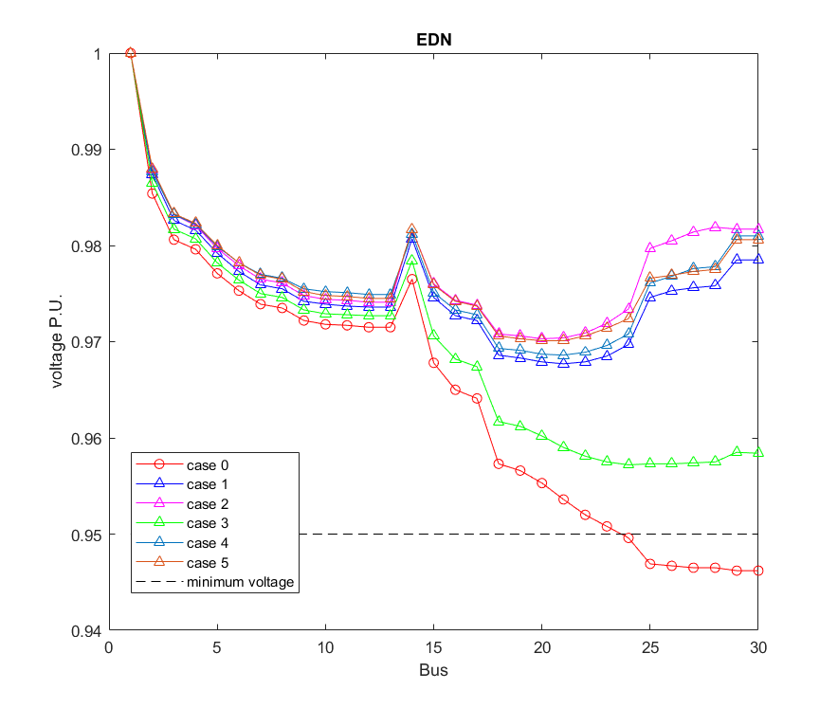

Figure ‎5‑10 Voltage profile for EDN system (objective function TVD minimization)

Fig. 5.11 and Fig. 5.12 shows the convergence curves of the AOA algorithm to reduce TVD using the DGs and capacitors for 34-bus test system. It is clear that, the AOA algorithm is able to reach the optimal solution with more accuracy and efficiency.

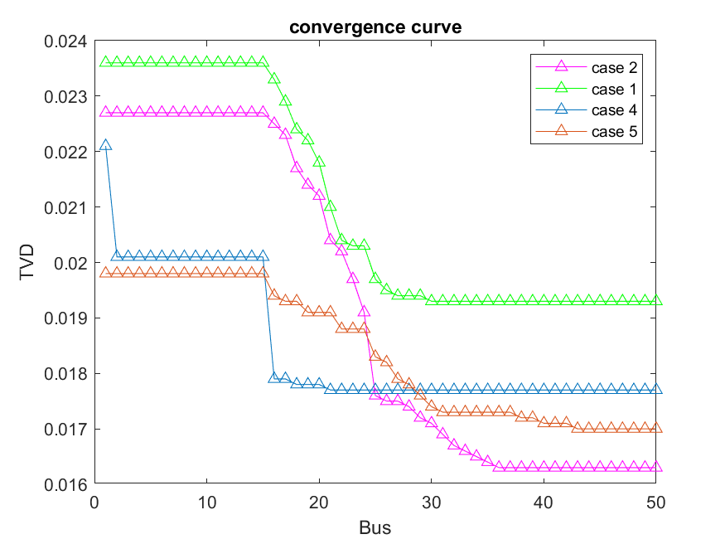

Figure ‎5‑11 convergence curve for EDN system (objective function TVD minimization)

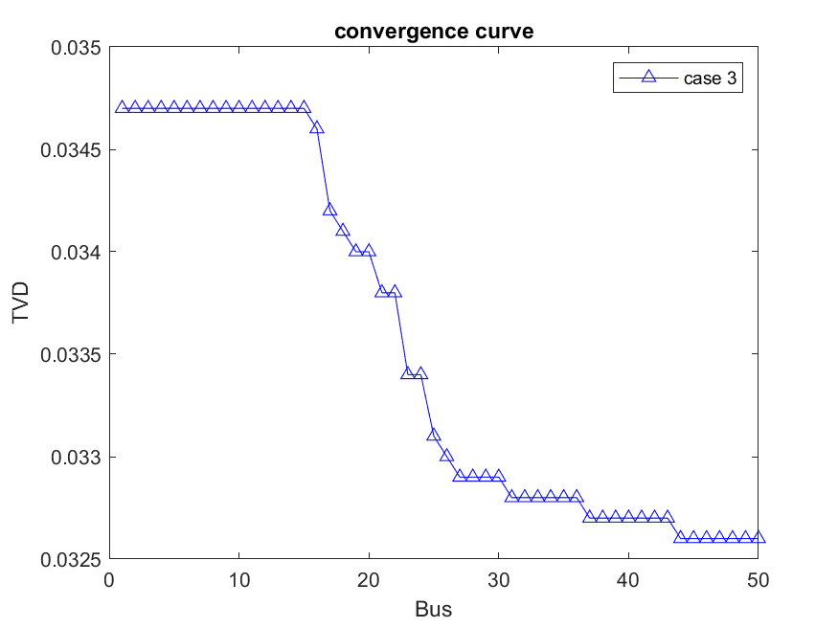

Figure ‎5‑12 convergence curve for EDN system (objective function TVD minimization)